Science Curriculum Map
Year Group | Autumn 1 | Autumn 2 | Spring 1 | Spring 2 | Summer 1 | Summer 2
Pre-school | Who am I?  (body parts and what they do) |  | Fairy Tales  (materials) | Space/Planet  (looking at space) | Mini Beast  (gardening, looking after living things and chick life cycles) | How do things grow?  (life cycles and healthy living)
Reception |  |  | Changing Seasons  (spotting similarities and differences and changes in the environment – weather changes, decay over time) | Space/Above  (Understanding similarities and differences in relation to places, objects, materials and living things. Relating this to not only our planet, but also to our country and even our region.) | Animals  (Making observations of animals and plants and explain why some things occur, and talk about changes.)
Year 1 | Plants | Every Day Materials | Everyday Materials | Animals and Their Needs | Animals and Their Needs | Seasons and Weather
Year 2 | Animals Including Humans-Growth | Animals including humans-Life cycles | Living Things and Their Habitats | Living things and their habitat- Habitats around the world | Plants and Their Growth | Every Day Materials
Year 3 | Animals Including Humans | Light | Geology  (rocks & soils) | Forces and Magnets | Plants and Their Growth | Plants and Pollination
Year 4 | Electricity | States of Matter | Sound | Living Things and Their Habitats | Animals Including Humans (the digestive system) | Living Things and Their Habitats (ecology)
Year 5 | Earth and Space | Forces | Properties and Changes of Materials | Living Things and Their Environments | Human Biology | Revision Unit
Year 6 | Light | Electricity | Classification of Living Things |  | Evolution and Inheritance  The Human Body (circulation) | Transition Unit

Year 3 | Scientific  Enquiry | Animals, including humans | Rocks | Forces and magnets | Plants | Light
Ask relevant questions and using
different types of scientific
enquiries to answer them
Set up simple practical enquiries,
comparative and fair tests
Make systematic observations,
take accurate measurements
using a range of equipment, incl.
thermometers & data loggers
Gather, record, classify and
present data in a variety of ways
to help in answering questions
Record findings using simple
scientific language, drawings,
labelled diagrams, keys, bar
charts, and tables
Report on findings from
enquiries, including oral and
written explanations, displays or
presentations of results and
conclusions
Use results to draw simple
conclusions, make predictions
for new values, suggest
improvements and raise further
questions
Identify differences, similarities
or changes related to simple
scientific ideas and processes
Use straightforward scientific
evidence to answer questions or
to support their findings

Topic | National curriculum | Progression | Lessons 1 | Lesson 2 | Lesson 3 | Lesson 4 | Lesson 5 | Lesson 6
Autumn 1  Animals including humans | - identify that animals, including humans, need the right types and amount of nutrition, and that they cannot make their own food; they get nutrition from what they eat  - identify that humans and some other animals have skeletons and muscles for support, protection and movement | Year 1:  - Identify and name parts of the human body.  - Explore the senses.  Year 2:  - Learn about basic needs for survival (food, water, air).  - Understand the importance of exercise, diet, and hygiene.  Year 3:  - Study nutrition, skeletons, and muscles.  Year 4:  - Focus on the digestive system and food chains.  Year 5:  - Examine life cycles of mammals, birds, insects, and amphibians.  - Explore human development and changes from birth to old age.  Year 6:  - Study the circulatory system, focusing on the heart, blood vessels, and blood.  Recognise the impact of diet, exercise, drugs, and lifestyle on health | - To Explore the Five Key Food Groups.  Children will identify and explore the five key food groups (fruits and vegetables, carbohydrates, proteins, dairy, and fats) and their importance for a balanced diet.   | - To Classify Nutrients from Foods.  Children will identify the different nutrients (e.g., vitamins, minerals, proteins, carbohydrates, fats) obtained from various foods.     | - To Explain Nutrient Transport.  Children will explain how nutrients, water, and oxygen are transported within animals and humans to support their health and functions.   | - To Classify Skeletal Systems.  Children will classify and identify the skeletal systems of humans and other animals, highlighting similarities and differences.   | - To Identify the Role of Muscles.  Children will explore and describe how muscles work with the skeleton to enable movement and provide support.   | - To Describe the Purpose of the Skeleton.  Children will describe the roles of the skeleton in humans and animals, focusing on support, protection, and movement.  
Vocabulary |  |  | 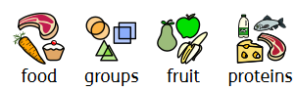 | 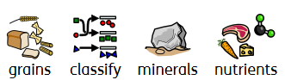 | 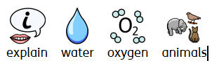 | 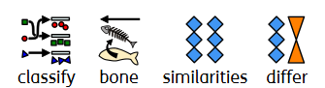 | 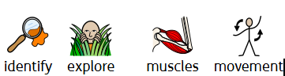 | 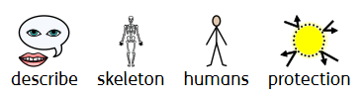
Autumn 2  Light | - recognise that they need light in order to see things and that dark is the absence of light  - notice that light is reflected from surfaces  - recognise that light from the sun can be dangerous and that there are ways to protect their eyes  - recognise that shadows are formed when the light from a light source is blocked by a solid object  - find patterns in the way that the size of shadows change | Year 3:  - Explore light sources, reflection, and shadows.  Year 6:  - Understand that light travels in straight lines.  - Explain how we see objects and why shadows have the same shape as the objects casting them. | - To Explore Light and Dark.  Children will explore and recognise the difference between light and dark, understanding that darkness is the absence of light. | - To Describe Light Reflection.  Children will observe and describe how light is reflected from different surfaces. | - To Explain and Demonstrate Shadow Formation.  Children will explain and demonstrate how shadows are formed when a solid object blocks light.   | - To Investigate Shadow Changes Throughout the Day.  Children will investigate and record how shadows change in position and size throughout the day. | - To Experiment with Shadow Sizes.  Children will explore patterns in how the size of shadows changes depending on the distance and angle of the light source. | - To Explain Sunlight Dangers.  Children will explain why direct sunlight can be harmful and identify ways to protect their eyes, such as using sunglasses or staying in the shade.
Vocabulary |  |  | 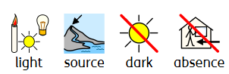 | 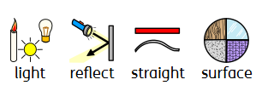 | 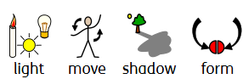 | 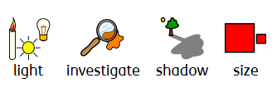 | 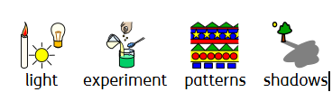 | 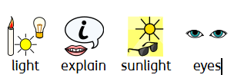
Spring 1  Rocks | - compare and group together different kinds of rocks on the basis of their appearance and simple physical properties  - describe in simple terms how fossils are formed when things that have lived are trapped within rock  - recognise that soils are made from rocks and organic matter |  | - To Classify Rocks by Properties.  Children will compare and group different kinds of rocks based on their appearance and simple physical properties. | - To Investigate Types of Rocks.  Children will explore and describe the characteristics of sedimentary, igneous, and metamorphic rocks. | - To Understand Fossil Formation.  Children will explain how fossils are formed when living things are trapped within rock layers over time. | - To Explore Soil Composition.  Children will investigate how soil is made from a mixture of rocks, organic matter, water, and air. | - To Examine Weathering Processes.  Children will explore how natural processes like water, wind, and temperature change contribute to the weathering and breakdown of rocks. | - To Use Scientific Observation.  Children will develop observational skills to examine closely and group rocks based on their unique characteristics and properties.
Vocabulary |  |  | 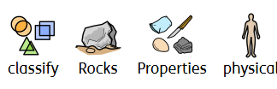 | 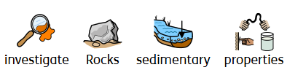 | 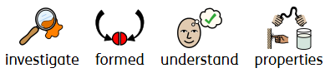 | 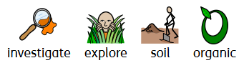 | 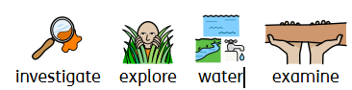 | 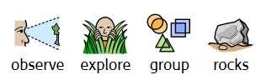
Spring 2  Forces and Magnets | - compare how things move on different surfaces  - notice that some forces need contact between 2 objects, but magnetic forces can act at a distance  - observe how magnets attract or repel each other and attract some materials and not others  - compare and group together a variety of everyday materials on the basis of whether they are attracted to a magnet, and identify some magnetic materials  - describe magnets as having 2 poles  - predict whether 2 magnets will attract or repel each other, depending on which poles are facing | Year 3:  - Investigate forces (pushes and pulls) and how they affect movement.  - Explore the role of magnets.  Year 5:  - Study gravity, air resistance, water resistance, and friction.  - Introduce mechanisms (levers, pulleys, gears) that amplify force.  Year 6:  - Apply understanding of forces to systems involving motion and energy transfer. | - To Compare Movement on Different Surfaces.  Children will investigate and compare how objects move on different surfaces, exploring the effects of friction. | - To Explore Different Types of Magnets.  Children will identify and explore different magnets, including bar magnets, ring magnets, and disc magnets. | - To Investigate Magnetic and Non-Magnetic Materials.  Children will test everyday objects to determine whether they are attracted to a magnet and classify materials as magnetic or non-magnetic. | - To Observe Non-Contact Magnetic Forces.  Children will observe how magnetic forces can act at a distance without direct contact between objects. | - To Understand Magnet Poles and Interaction.  Children will describe magnets as having two poles and predict whether two magnets will attract or repel based on the poles facing each other. | - To Explore Everyday Uses of Magnets.  Children will explore and identify practical uses of magnets in everyday life, such as in compasses, fridge magnets, and electronic devices.
Vocabulary
Summer 1  Plants- and their growth | - identify and describe the functions of different parts of flowering plants. roots, stem/trunk, leaves and flowers  - explore the requirements of plants for life and growth (air, light, water, nutrients from soil, and room to grow) and how they vary from plant to plant  - investigate the way in which water is transported within plants | Year 1:  - Identify common plants and trees.  - Explore basic parts of plants (roots, stems, leaves, flowers).  Year 2:  - Investigate plant growth and requirements for life.  Year 3:  - Study plant functions (water transport, pollination, seed dispersal).  - Introduce the life cycle of plants, including reproduction. | - To Identify Plant Parts and Functions.  Children will identify and describe the functions of different parts of flowering plants and trees, including roots, stems/trunks, leaves, and flowers. | - To Explore Plant Survival Needs.  Children will explore and describe the various needs of plants for survival, including air, light, water, nutrients from soil, and space to grow. | - To Understand the Role of Flowers in the Plant Life Cycle.  Children will explore the role of flowers in the life cycle of a plant, particularly in reproduction. | - To Investigate Water Transport in Plants.  Children will observe and describe how water is transported through plants, from the roots to the leaves. | - To Describe the Plant Life Cycle.  Children will describe the stages of the plant life cycle, focusing on the importance of flowers in pollination and seed production. | - To Compare Plant Requirements.  Children will compare the different growth and survival needs of various plants, recognising how these needs can vary from species to species.
Vocabulary
Summer 2  Plants and pollination | - explore the part that flowers play in the life cycle of flowering plants, including pollination, seed formation and seed dispersal | Year 1:  - Identify common plants and trees.  - Explore basic parts of plants (roots, stems, leaves, flowers).  Year 2:  - Investigate plant growth and requirements for life.  Year 3:  - Study plant functions (water transport, pollination, seed dispersal).  - Introduce the life cycle of plants, including reproduction. | - To Explore the Role of Flowers in Plant Reproduction.  Children will investigate and describe the role of flowers in the life cycle of flowering plants, focusing on pollination. | - To Understand Pollination.  Children will explore how pollination occurs in flowers, including the role of insects, wind, and animals in transferring pollen. | - To Describe Seed Formation.  Children will describe how seeds are formed in flowers after pollination and the role of the flower’s parts in this process. | - To Investigate Seed Dispersal.  Children will explore the different methods of seed dispersal, such as by wind, water, or animals, and how this helps plants grow in new locations. | - To Compare Flowering Plant Life Cycles.  Children will compare the life cycles of different flowering plants, focusing on how flowers contribute to the cycle. | - To Explore the Importance of Flowers for Plant Growth.  Children will investigate how flowers are essential for the reproduction and survival of plants, ensuring the continuation of the species.
Vocabulary

Foundation Knowledge (Years 1–2):
- Focus on observation and identification (e.g., basic habitats, body parts, simple material properties).
Building Understanding (Years 3–4):
- Develop functional understanding (e.g., digestion, simple circuits, forces, states of matter).
Applying Concepts (Years 5–6):
- Explore complex systems (e.g., circulatory system, evolution, advanced circuits).
- Investigate broader scientific principles and their applications (e.g., adaptation, forces in mechanisms, classification).

