
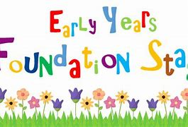
Welcome to EYFS
Nursery - Ms Rodrigues, Ms Hand and Ms Emira.
Reception – Miss Hadji
We are so excited to have you join our community. This is the beginning of a wonderful journey, and we feel privileged to be part of your child’s early years.
At our EYFS, we strive to create a safe, nurturing, and stimulating environment where every child can grow, learn, and thrive. We believe in working closely with families to support each child’s individual development and ensure they feel happy, confident, and valued.

PE/Swimming:
P.E is on Wednesday. Please ensure children are wearing appropriate clothing and footwear for this.

School Uniform:
We encourage children to wear school uniform. If they are not wearing school uniform, please dress them in comfortable clothing.
Reading:
We strongly recommend that children are read to at home every night. Hearing someone read supports language and vocabulary development. Reading records will be given out.
Class Dojo:
Class dojo will be used to showcase children’s learning and activities. Please do check it regularly for important dates and updates.




Outdoor learning/ Forest School:
We love learning outdoors in EYFS! Our children have regular opportunities to explore, investigate and discover the natural world, developing their curiosity, confidence, physical skills and independence.
Forest School takes place every Tuesday, giving children the chance to learn through hands-on experiences in nature, explore natural materials, take appropriate risks and develop resilience. Please ensure your child comes to school with wellies and a rain jacket so they can enjoy their Forest School experience whatever the weather!

