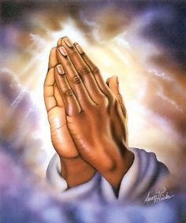


Homework
Please make sure all work is completed on time.
Please make sure you keep up to date with everything send on class dojo.
Important Dates:
Jeans for genes day- 25/09/26
Harvest fast day- 2/10/26
Hello yellow- 09/10/2026
Black history day- 23/10/26
Year 5 Mass Dates:
Whole School Mass – 07/09/2026
08/12/2026
Year 5 mass- 07/10/2026
11/11/2026
16/12/2026

Class Dojo:
Class dojo is the quickest and most up to date way of communicating with each other. Therefore, please check Class dojo regularly. Feel free to message with any queries and we will respond within 5 working days. If it is urgent, please contact the office.
READING/RWI:
In Year 5, reading is crucial. Children are expected to read daily for 20 minutes and have their reading record checked and signed by parents/ a detailed summary of what they read that day.

PE:
P.E is on Thursdays and Friday. Ensure that children have the correct P.E and appropriate footwear.
School Uniform: Children should be wearing their winter uniform and school shoes.
It’s the start of a new school year! 🍂
Welcome back to Year 5! We’re excited for a fantastic year filled with learning, challenges and new adventures. This is an important year as pupils grow in confidence, independence and responsibility, preparing for the exciting journey ahead into Year 6. 🌟
Homework:
Children will be set homework regularly, which will be posted on Class dojo and/or Doodle/Homework textbook. Please do not hesitate to contact me for passwords.

Children have been given a homework book to complete homework in every day.
Please ensure this gets completed and send back to school every day.