Year 2 Curriculum Map
 | Autumn Term |  | Spring Term |  |  |  | Summer Term
 | 1st | 2nd | 1st |  | 2nd |  | 1st | 2nd
Literacy | RWI Phonics | RWI Phonics | RWI Phonics |  | RWI Phonics |  | RWI Phonics | RWI Phonics
Literacy | About Orangutans  Full stops  Capital letters  Adjectives  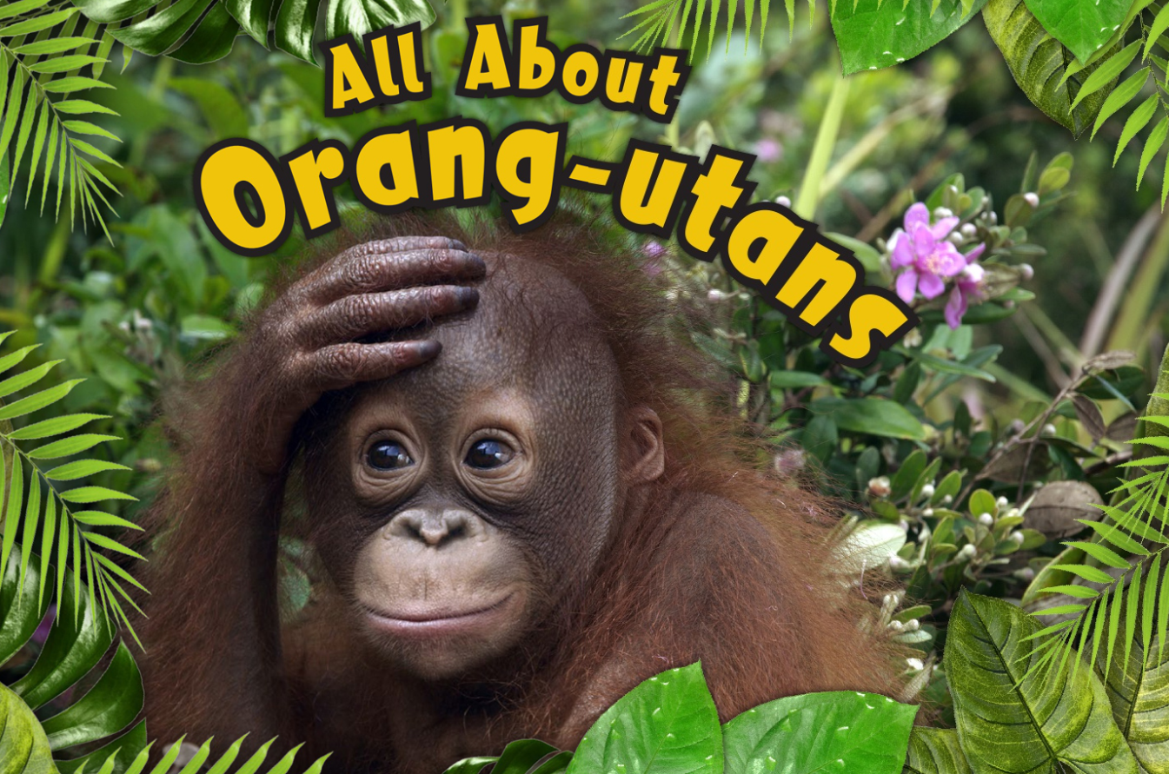 | Silly Billy  Punctuation marks  Past and present  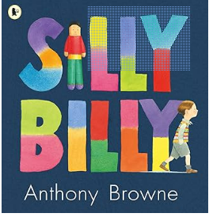 | Does chocolate grow on trees?  Adverbs  Capital letters  Nouns  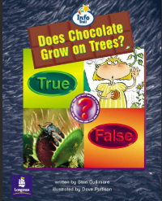 |  | City of Fire  Subordinating conjunctions  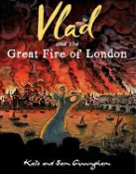  Irregular past tense/verbs |  | The Most Unusual place…  punctuation  Suffixes  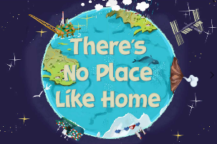  -ment, -ness, - ly | Baby Brains  Verbs  Using different sentence types (compound)  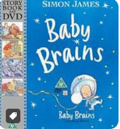
Literacy | Handa’s Hen  Time connectives  Sequencing  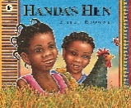 | Operation Night Monster  Suffixes – ing/er/est/ed  Apostrophes (contractions)  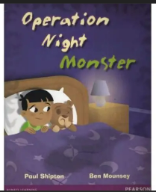 | Don’t read this book  Expanded noun phrases  Exclamation marks  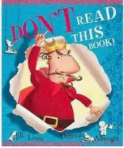 |  | Shakespeare Week  (Rome & Juliet)  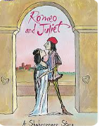 |  | The Man who wore all his clothes  Expanded noun phrases  Commas  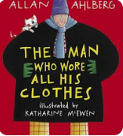 | Penny Dreadful  And, or, but  Past/present progressive  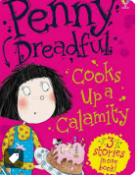
Literacy | A Squash and a Squeeze  Verbs  Exclamation marks  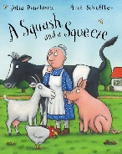 | Man on the moon  Conjunctions – and, but, because  Apostrophes (possession)  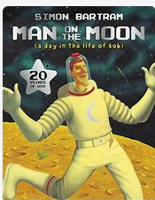 | Maximus and the Beanstalk  Punctuation (capital letters, full stops)  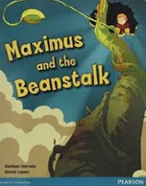  Suffixes ful/less |  | Exploring poetic form  Shape poem |  | Anancy and MR DRY BONE  Using different sentence types (compound)  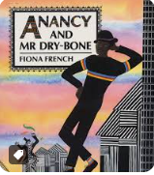 | Exploring poetic language
Numeracy | Number: Place Value  Number: Addition and Subtraction  Geometry: Shape |  | Measurement: Money  Number: Multiplication and Division  Measurement: Length and Height  Measurement: Mass, Capacity and Temperature |  |  |  | Statistics  Number: Fractions  Geometry: Position and Direction  Problem solving  Measurement: Time
RE | Branch 1: Creation and Covenant  Noah Sacrament of Baptism | Branch 2: Prophecy and Promise  Nativity – visitation, Magnificat, Advent | Branch 3: Galilee to Jerusalem  Ministry parables and miracles |  | Branch 4: Desert to Garden  Holy Week Easter vigil |  | Branch 5: To the Ends of the Earth  Ascension, Pentecost, Conversion | Branch 6:  Who is my neighbour?  Judaism – Sabbath & Hebrew
PSHE | New Beginnings | Getting on & Falling out | Going for Goals |  | Good to Be Me |  | Relationships | Changes
RSE |  | Let the children come | I am unique  Girls and Boys  Clean and Healthy |  | Feelings, Likes and Dislikes  Feeling Inside Out  Super Susie gets angry |  | The cycle of life | Three in One  Who is my neighbour?  The communities we live in
Topic  Taught in blocks | HISTORY  Romans in Britain  GEOGRAPHY  Spatial sense  SCIENCE  Animals Including Humans  COMPUTING  Online safety  Spreadsheets | ART & DT  Elements of Art Shape and texture  DT  Making axels and textiles with tools and materials  SCIENCE  Animals Including Humans  COMPUTING  Get up and Go |  | HISTORY  Anglo-Saxons and Vikings  GEOGRAPHY  Northern Europe  SCIENCE  Living Things and Their Habitats  COMPUTING  Ocean exploration |  | ART & DT  Medieval Art  DT  Cooking  SCIENCE  Living Things and Their Habitats  COMPUTING  Botanists | HISTORY  Normans  GEOGRAPHY  Regions of the UK  SCIENCE  Every Day Materials  COMPUTING  Book creators |  | ART & DT  Portraits and self-portraits  DT  Nutrition  SCIENCE  Plants and Their Growth  COMPUTING  Game developers
Music | Hands, Feet, Heart | Ho ho ho | I want to play in a band |  | Zoo time |  | Friendship song | Reflect, rewind and replay
PE | Fundamentals  Fitness | Ball skills unit 1  Gymnastics | Ball skills unit 2  Dance |  | Striking & Fielding  Net & Wall |  | Sending & Receiving  Invasion games | Athletics  Team Building
Celebrations/  Trips | International day  Black history week  E-safety and coding week  Maths week | Anti- Bullying week  Remembrance Day  Harvest Festival | National Poetry month  World faith week  Healthy school |  | MFL week  Book week  British History Week |  | Art & DT week | Travellers month  SRE week  Science Week  Sports Day  British Museum

