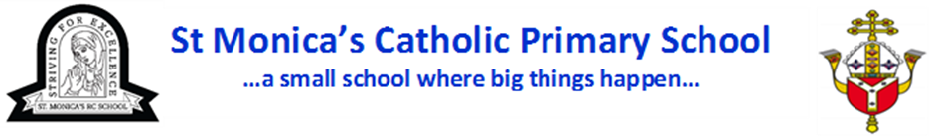

Religious Education Policy

Policy Reviewed: | September 2026
Policy approved by Governing Body:  Chair of Governors’ signature: | 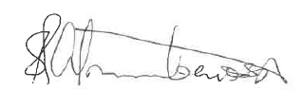
Review Cycle: | Annually
Date of Next Review: | September 2027

Rationale of Religious Education.

- Religious Education is central to the educative mission of the Church.
‘At the heart of Catholic education lies the Christian vision of the human person. This vision is expressed and explored in Religious Education.’
- In a Catholic school, at the core of the core, is Religious Education, for the sake of which Catholic schools exist in the first place.

The Aims of Religious Education
- to engage in a systematic study of the mystery of God, of the life and teaching of Jesus Christ, the teachings of the Church, the central beliefs that Catholics hold, the basis for them and the relationship between faith and life;
- to enable pupils continually to deepen their religious and theological understanding and be able to communicate this effectively;
- to present an authentic vision of the Church’s moral and social teaching to provide pupils with a sure guide for living and the tools to critically engage with contemporary culture and society;
- to give pupils an understanding of the religions and worldviews present in the world today and the skills to engage in respectful and fruitful dialogue with those whose worldviews differ from their own;
- to develop the critical faculties of pupils so to bring clarity to the relationship between faith and life, and between faith and culture;
- to stimulate pupils’ imagination and provoke a desire for personal meaning as revealed in the truth of the Catholic faith;
- to enable pupils to relate the knowledge gained through religious education to their understanding of other subjects in the curriculum

Outcome of Religious Education
The outcome of Religious Education is religiously literate and engaged young people who have the knowledge, understanding and skills – appropriate to their age and capacity – to reflect spiritually, and think ethically and theologically, and who are aware of the demands of religious commitment in everyday life.

Religious Education at the heart of the curriculum
- Religious education is the core of the core curriculum and is to be the source and summit of the whole curriculum.
- Religious education is an academic discipline with the same systematic demands and rigour as other disciplines.
- Religious education is to be delivered within a broad and balanced curriculum, where it informs every aspect of the curriculum. Every other subject is to be informed by religious education and have a strong relationship with it.
- In each year of compulsory schooling, religious education is to be taught for at least 10% curriculum time within each repeating cycle of the regular school timetable.
- In each year of sixth form schooling, religious education is to be taught for at least 5% curriculum time within each repeating cycle of the regular school timetable.
Programme of Study:
As a Catholic school St. Monica’s is required to comply with the Religious Education Directory (2023). The RED 2023 provides a model curriculum which this school follows in all year groups – from Nursery to Year 6. St. Monica’s uses Catholic Plus to support the teaching of R.E and to resource the model curriculum (RED 2023).
Curriculum Structure
The model curriculum has six components known as branches which map helpfully onto the six half-terms of the school year. Five of these have a core theme which invites pupils to learn about an aspect of Revelation, Scripture, life in Christ, and life in the Church, and to discern what their learning means academically and experientially enabling them to see, judge, and act through a deeper knowledge of the Christian faith. The Encounter & Dialogue branch involves the study of other religions, encountering other pathways of belief drawing on the teaching of the Church about intercultural dialogue.
Detail of the curriculum can be found here: Religious Education Directory 2023
Assessment, Monitoring, Recording and Reporting
- Assessment of standards is carried out against the Expected Outcomes in RED 2023.
- Assessment moderation / standardisation takes place in school amongst colleagues, with our partner school, St. Edmund’s, within our Lux Mundi trust, at deanery meetings and at diocesan meetings.
- Monitoring of teaching and learning in Religious Education takes place in line with our school monitoring structures.
- Progress and achievement is recorded and tracked in line with our school assessment policy.
- Progress and achievement in Religious Education is reported to Governors at least termly in line with other core subjects.
- Progress and achievement in Religious Education is reported to parents/carers each year in line with other core subjects.

Leadership of the subject:
Ms Rodrigues is the RE Lead. We also have a R.E team: Ms Catarina Rodrigues, Mrs Lenka Jallow and June Downey. The R.E lead has responsibility for leading, managing and supporting the delivery of Religious Education and the continuous professional development of teachers in Religious Education
Mr. Fadoju is the link governor with responsibility for Religious Education.
Policy Review:
This policy will be reviewed and monitored by Ms Rodrigues and the R.E team, and approved by the Governing Body. This Policy will be updated every two years.

Religious Education in Catholic Schools, Bishops’ Conference of England and Wales, 2000, para 4
Religious Education Directory 2023, p13
Religious Education Directory 2022 p6
Religious Education Directory 2023, p6

